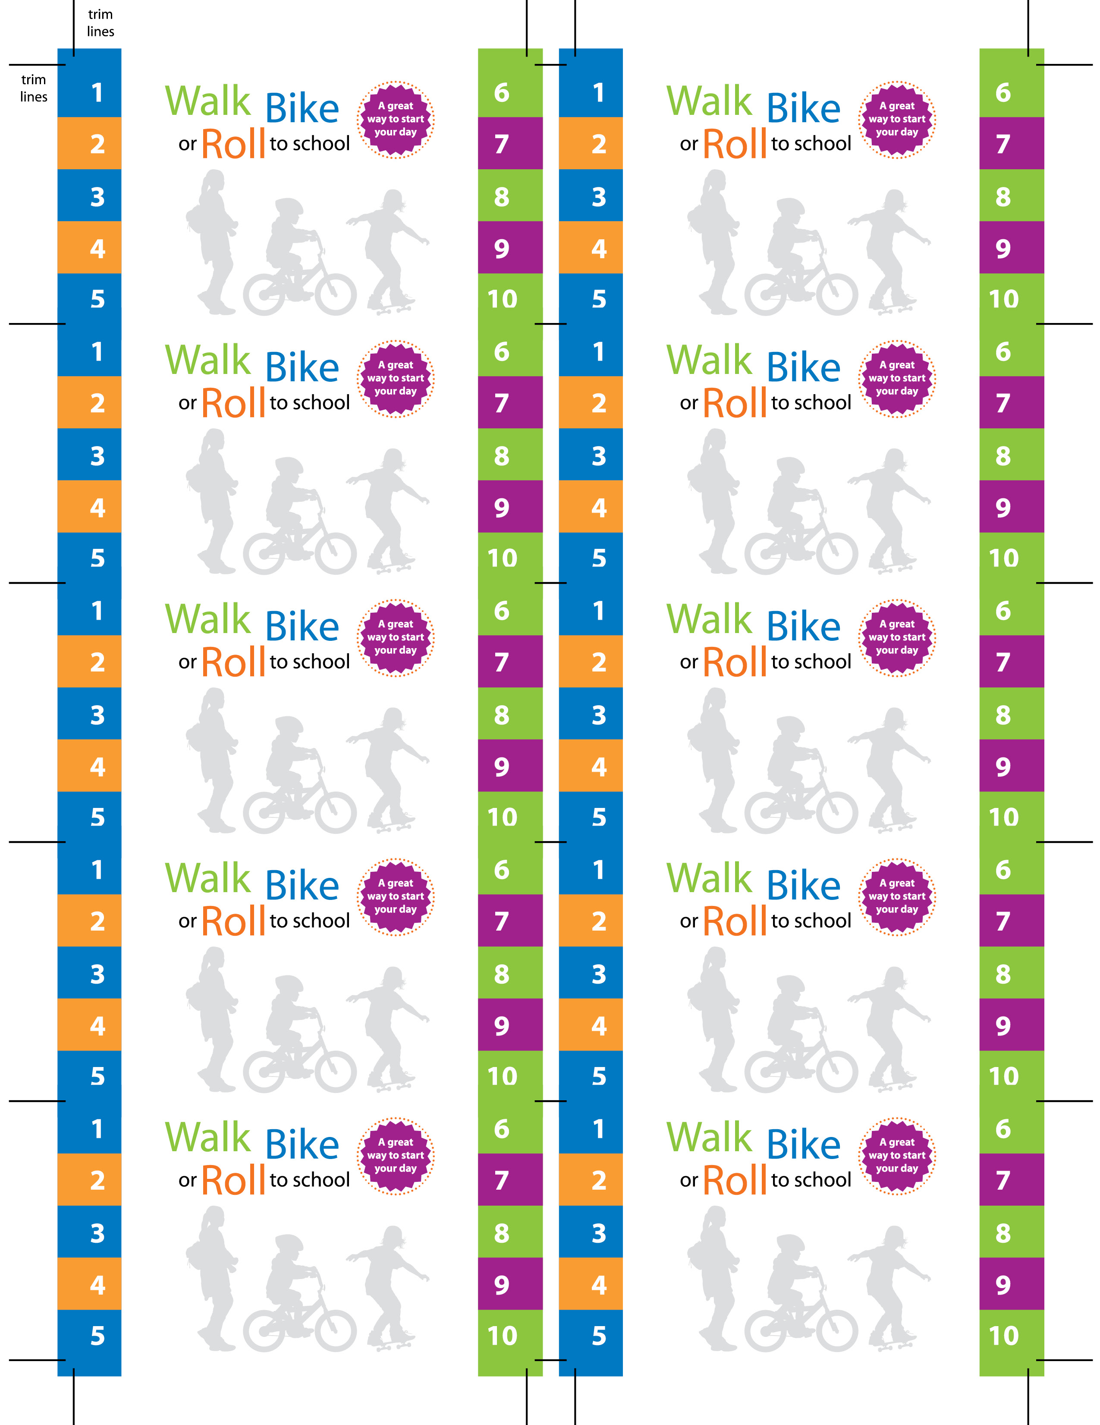
Name:

Frequent Walker, Biker and Roller punch card. Earn special prize after 10 punches.

